**Boot Sector Interpretation**

* 00-02: eb 3c 90 Instructions to jump to boot code
* 03-0a: 4d 53 44 4f 53 35 2e 30
* Name string (MSDOS5.0)
* 0b-0c: 00 02 Bytes/sector (0x0200 = 512)
* 0d : 01 Sectors/cluster (1)
* 0e-0f: 01 00 Size of reserved area (1 sector)
* 10 : 02 Number of FATs (2)
* 11-12: e0 00 Max. number of root directory entries (0x00e0 = 224)
* 13-14: 40 0b Total number of sectors (0x0b40 = 2,880)
* 15 : f0 Media type (removable)
* 16-17: 09 00 FAT size (0x0009 = 9 sectors)
* 18-19: 12 00 Sectors/track (0x0012 = 18)
* 1a-1b: 02 00 Number of heads (0x0002 = 2)
* 1c-1f: 00 00 00 00 Number of sector before partition (0)
* 20-23: 00 00 00 00 Total number of sectors (0 because 2B value not equal 0)
* 24 : 00 Drive number (0)
* 25 : 00 Unused
* 26 : 29 Extended boot signature
* 27-2a: cf cd b1 c4 Volume serial number (C4B1-CDCF)
* 2b-35: 4e 4f 20 4e 41 4d 45 20 20 20 20
* Volume label ("NO NAME ")
* 36-3d: 46 41 54 31 32 20 20 20
* File system type label ("FAT12 ")
* 3e-1fd : [snip] Not used
* 1fe-1ff: 55 aa Signature value (0xaa55)

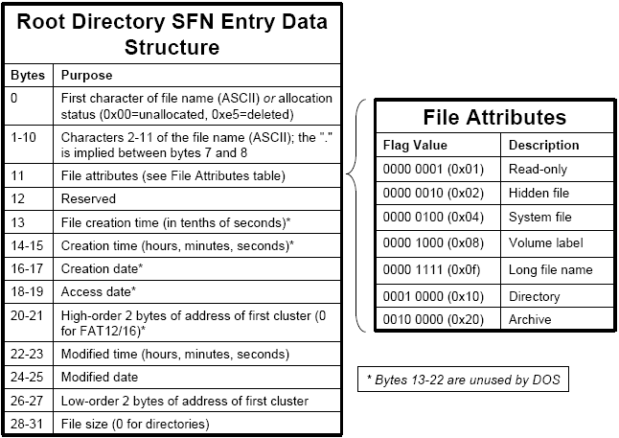

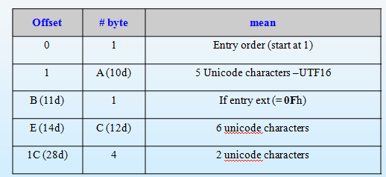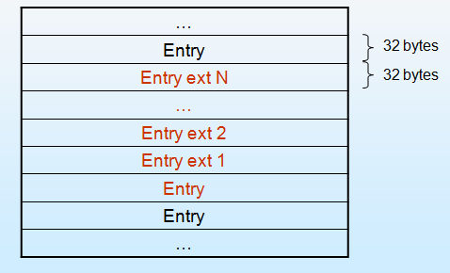Long file name Entry ext

**FAT**

